

Foundations of Programming

Assignment No. : 06
PROBLEM STATEMENT:Write a C function to compute the factorial of a number with and without recursion.

OBJECTIVE:

To demonstrate two different approaches for calculating the factorial of a number: iterative (non-recursive) and recursive, showcasing the versatility of problem-solving methods in programming.

THEORY:
- Explain the difference between the iterative and recursive approaches to calculating the factorial of a number.
Iterative Approach: This method uses loops (like for or while) to repeat a block of code. For a factorial, it starts with a variable set to 1 and repeatedly multiplies it by every number up to the target number $n$.
Pros/Cons: It is highly memory efficient because it uses a single continuous loop and updates the same variables. However, the code might look slightly longer than the recursive version.

- What is the base case in the recursive function for computing factorials, and why is it necessary?
The base case for computing a factorial is when the input $n$ is $0$ or $1$. The function explicitly returns $1$ in this scenario without making any further recursive calls (e.g., if (n == 0 || n == 1) return 1;).
The base case acts as the stopping condition for the recursion. Without a base case, the function would keep subtracting 1 and calling itself infinitely (into negative numbers), which would quickly exhaust the computer's memory and cause a stack overflow crash.

- How does the program handle invalid input, such as negative numbers, and why is this important?
The program typically uses a simple if condition right after accepting the user's input (e.g., if (num < 0)). If the condition is met, the program prints an error message ("Factorial of a negative number doesn't exist") and bypasses the calculation entirely.
1. Mathematical Accuracy: In standard mathematics, factorials are only defined for non-negative integers.
2. Program Stability: If a negative number were passed into the recursive function, it would never reach the base case of $0$ or $1$. It would count downwards endlessly (e.g., -1, -2, -3...), causing an infinite loop and crashing the system. Validating the input prevents these fatal errors.

PLATFORM: Linux
CODE:
#include <stdio.h>
unsigned long long factorial_iterative(int n);
unsigned long long factorial_recursive(int n);

int main() {
int num;

printf("Enter a positive integer: ");
scanf("%d", &num);

if (num < 0) {
printf("Error: Factorial of a negative number doesn't exist.\n");
} else {
// Call and print results from both functions
printf("Factorial of %d (Without Recursion): %llu\n", num, factorial_iterative(num));
printf("Factorial of %d (With Recursion): %llu\n", num, factorial_recursive(num));
}

return 0;
}
unsigned long long factorial_iterative(int n) {
unsigned long long fact = 1;
for (int i = 1; i <= n; i++) {
fact *= i;
}
return fact;
}
unsigned long long factorial_recursive(int n) {
// Base case: factorial of 0 or 1 is 1
if (n == 0 || n == 1) {
return 1;
}
return n * factorial_recursive(n - 1);
}

INPUT AND OUTPUT:
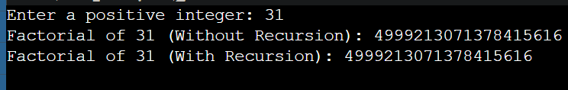
CONCLUSION: Thus, we have successfully executed factorial of a number with and without recursion.

